**Lab # 11**

### Objective:

Draw the forward & reverse characteristics of a P.N. junction diode.

### Equipment:

* P-N junction diode
* DC power supply
* Multimeter (for measuring voltage and current)
* Resistor (for current limiting)
* Breadboard and connecting wires
* Ammeter (optional, for precise current measurements)
* Voltmeter (optional, for precise voltage measurements)

### Theory:

A P-N junction diode is a semiconductor device with distinct electrical characteristics in forward andreverse bia:

* **Forward Bias**: When the diode is forward-biased, the P-type material is connected to the positive terminal and the N-type material to the negative terminal of the power supply. The diode conducts current once the forward voltage exceeds the threshold voltage (approximately 0.7V for silicon diodes). The relationship between current and voltage is exponential.
* **Reverse Bias**: When the diode is reverse-biased, the P-type material is connected to the negative terminal and the N-type material to the positive terminal. In this configuration, the diode ideally blocks current flow except for a very small leakage current. When the reverse voltage reaches the breakdown voltage, significant current can flow if the diode is not designed to handle such voltages.

### Procedure:

1. **Forward Bias Measurement**:
   * Connect the diode in series with a resistor on a breadboard.
   * Connect this series combination to the DC power supply.
   * Start with a voltage of 0V and gradually increase the voltage in small steps (e.g., 0.1V).
   * For each voltage step, measure and record the voltage across the diode and the current through the circuit.
2. **Reverse Bias Measurement**:
   * Reverse the connections of the diode so that the P-type material is connected to the negative terminal of the power supply and the N-type material to the positive terminal.
   * Increase the reverse voltage in small steps (e.g., -0.1V).
   * Measure and record the reverse voltage and the current through the diode at each step until reaching the breakdown voltage.

### Observation Table:

#### Forward Bias Characteristics:

|  |  |
| --- | --- |
|  |  |
|  |  |

#### Reverse Bias Characteristics:

|  |  |
| --- | --- |
|  |  |
|  |  |

### Results:

* The forward bias characteristic curve shows that the current increases exponentially with the voltage beyond the threshold voltage (~0.7V), confirming the diode's exponential I-V relationship in forward bias.
* The reverse bias characteristic curve shows that the reverse current remains minimal and nearly constant until the reverse breakdown voltage is approached or exceeded.

### Conclusion:

The practical experiment successfully demonstrated the forward anreversecharacteristicsofthePNjunction diode. The diode exhibits an exponential increase in current with voltage in the forward direction and

maintains a small leakage current in the reverse direction, illustrating its behavior as aunidirectional current conductor and its blocking capability in reverse bias.

### Safety Precautions:

* Ensure the power supply voltage does not exceed the maximum reverse voltage rating of the diode to prevent damage.
* Use a current-limiting resistor in series to avoid excessive current that could overheat or damage the diode.
* Handle all electrical equipment and connections carefully to avoid electric shock and component damage.

### Circuit Diagram:

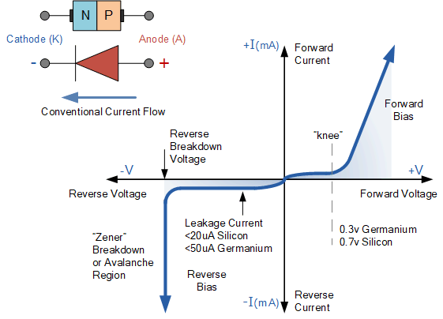

### POST LAB:

### **What would you observe if the diode was connected in reverse bias and the reverse voltage was increased beyond the breakdown voltage?**

_____________________________________________________________________________­_

______________________________________________________________________________

______________________________________________________________________________

**How does the current behavior of the diode in forward bias differ from that in reverse bias?**

_____________________________________________________________________________­_

______________________________________________________________________________

______________________________________________________________________________

**Discuss the impact of the series resistor in the forward bias circuit. Why is it necessary?**

_____________________________________________________________________________­_

______________________________________________________________________________

______________________________________________________________________________

**What can be inferred from the flat region of the reverse bias characteristic curve?**

_____________________________________________________________________________­_

______________________________________________________________________________

______________________________________________________________________________

**Why is it important to measure both forward and reverse characteristics of a diode in this experiment?**

_____________________________________________________________________________­_

______________________________________________________________________________

______________________________________________________________________________